# Template for a 2019 ASABE Annual Meeting Paper

Use this template for correct online indexing and searches.

All meeting papers will be included in the in the ASABE Technical Library at <http://elibrary.asabe.org/toc.asp>.

For your paper to be posted online ***before*** the meeting, upload your completed paper by   
May 1, 2019, at <https://www.eiseverywhere.com/eSites/2019aim/Homepage>.

Papers uploaded after May 1, 2019, will be posted after the meeting.

The ITSC Paper Awards deadline is April 22, 2019.

The name of your Microsoft Word file should match your paper number.   
Example file name: 1900987.docx

You must enter your paper number in THREE locations below.

Have questions? Click on the [FAQ](http://www.asabe.org/AIMpaperFAQ).

* Please follow these instructions. Processing time is delayed when these instructions are not followed.
* The tables below are necessary for online indexing of author names. They will not be printed with your paper.
* The title, abstract, keywords, etc. of your paper ***must*** have certain [Word styles](http://wordfaqs.mvps.org/DisplayStyles.htm) for online searches.
* There are new (2018) instructions below about fonts, styles, and references. Use website links for help. Use Times New Roman font for text except inside figures. Within figures, use a sans serif font, such as Arial, for clarity; however, the caption under the figure should be Times New Roman. For citations in the text, use the name, date system. For the references section at the end of the paper, use *APA 6th* style. These changes make this paper like our journal format. You may want to publish this paper in our journals. See [www.asabe.org/SubmitJournalManuscript](http://www.asabe.org/SubmitJournalManuscript) for more.

Revised 12/31/2018.

See the ASABE website for more [information for authors](http://www.asabe.org/publications/authors.aspx) and about ASABE [templates](https://www.asabe.org/ManuscriptTemplates).

Author 1 (one author only)

|  |  |  |  |  |  |  |
| --- | --- | --- | --- | --- | --- | --- |
| First Name  (or initial) | Middle Name (or initial) | Surname | Suffix  (Jr., III, etc.) | Role (ASABE member, etc.) | Email | Contact author? yes or no |
|  |  |  |  |  |  |  |

Affiliation for Author 1

|  |  |  |  |
| --- | --- | --- | --- |
| Organization | Address | Country | Phone for contact author |
|  |  |  |  |

Author 2 (one author only)

|  |  |  |  |  |  |  |
| --- | --- | --- | --- | --- | --- | --- |
| First Name  (or initial) | Middle Name (or initial) | Surname | Suffix  (Jr., III, etc.) | Role (ASABE member, etc.) | Email | Contact author? yes or no |
|  |  |  |  |  |  |  |

Affiliation for Author 2

|  |  |  |  |
| --- | --- | --- | --- |
| Organization | Address | Country | Phone for contact author |
|  |  |  |  |

Author 3—repeat the Author and Affiliation tables for each additional author

|  |  |  |  |  |  |  |
| --- | --- | --- | --- | --- | --- | --- |
| First Name  (or initial) | Middle Name (or initial) | Surname | Suffix  (Jr., III, etc.) | Role (ASABE member, etc.) | Email | Contact author? yes or no |
|  |  |  |  |  |  |  |

Affiliation

|  |  |  |  |
| --- | --- | --- | --- |
| Organization | Address | Country | Phone for contact author |
|  |  |  |  |

Paper number and page range

|  |
| --- |
| Paper number on the line below |
|  |
| Pages 1-\_\_\_\_\_ |

|  |  |
| --- | --- |
| ASABE_all_blue | An ASABE Meeting Presentation  DOI: https://doi.org/10.13031/aim.20  Paper Number: 1900773 |

Development of a Robotic Inspection System for Early Detection and Locating of Biotic Stresses in Greenhouse Crops

T. Mhabary1, A. Ozeri1, S.Y. Nof2, Y. Tao3 and A. Bechar1

1 - Institute of Agricultural Engineering, Agricultural Research Organization (ARO), Volcani Center, Israel

2- PRISM Center and School of Industrial Engineering, Purdue University, USA

3- Fischell Department of Bioengineering, [University Of Maryland](https://umd.edu/), USA

Written for presentation at the

2019 ASABE Annual International Meeting

Sponsored by ASABE

Boston, Massachusetts

July 7–10, 2019

**Abstract.** **A major challenge in greenhouse crops is the inability to detect stresses and risks early enough preventing uncontrolled spreading of stresses causing irreparable damage. Often, although the knowledge how to handle a stress is available, due to late detection it is too late to act correctly. Hence, farmers often react wastefully. Therefore, there is a compelling need to develop an effective, affordable robotic inspection system using close sensing.**

**The objective of this research is to develop a human integrated intelligent sensory-robotic system for inspection and early detection of biotic stresses and risks in greenhouse crops. The system developed consists a mobile platform, a manipulator mounted on the platform and a sensory system mounted on the platform and the manipulator. A mechanical design of the platform was conducted and the robotic platform was developed.**

**3D mapping algorithms were developed and tested in lab and greenhouse environments using two depth cameras: Microsoft Kinect – TOF camera and Intel RealSense D435 stereo camera. Autonomous real time navigation algorithms were tested successfully. The algorithms were developed using the 3D mapping model, depth cameras and encoders mounted on the platform wheels.**

**A collaborative human robot control algorithm was also developed to guide the robotic system in performing the disease detection task, implemented on the robotic platform and tested in experiments in lab and orchard environments. In these experiments the robotic platform was located in Israel and controlled in real time using the collaborative control system from Purdue University, about 10,000 km away from the robotic platform. Commands, images and data were transferred between these two locations, representing a system controlled by a farmer from a remote location.**

**An advanced image analysis for early detection of TSWV disease based on 'outlier removal auxiliary classifier generative adversarial nets' (OR-AC-GAN) algorithm was developed at the University of Maryland, representing an expert center for disease detection.**

The abstract is often the only part of the paper to be read, so include your major findings in a useful and concise manner. Include a problem statement, objectives, brief methods, quantitative results, and the significance of your findings. The abstract should be no more than 250 words long.

**Keywords.** **Agricultural robotics, Autonomous driving, SLAM, Early Disease Detection, ROS, Hyper Spectral,**  Put keywords in alphabetical order. List both specific and general terms that will aid in searches..

# Introduction

A major challenge in greenhouse crops is the inability to detect stresses and risks early enough preventing uncontrolled spreading of stresses causing irreparable damage. Often, although the knowledge how to handle a stress is available, due to late detection it is too late to act correctly. Hence, farmers often react wastefully. Therefore, there is a compelling need to develop an effective, affordable robotic inspection system using close sensing. In greenhouse environments, the conditions are especially controlled to maximize the crops growth rate and production, which can expose plants to biotic and abiotic risks. Up to 40% of the world crop production is lost through diseases, insects and weeds, according to a 2013 estimate by the Food and Agriculture Organization of the United Nations. Due to scarce human resources, time limitations, and the high cost of current monitoring methods, mostly manual inspection procedures can lead to inaccurate use of nutrients and late detection of diseases. In addition, as farm sizes increase and the availability of labor decreases, more effective agricultural practices are necessary. A high frequency, high resolution and optimally planned crop monitoring apparatus, collaboratively supervised by a human operator to reduce cost, reinforced by agile robotics and spectral sensing technologies could lead to intelligent, efficient, safe, and more effective biotic and abiotic stress management.

The objective of this research is to develop and enable for the first time a human integrated intelligent sensory-robotic system for inspection and early detection of biotic and abiotic stresses and risks in greenhouse crops. This novel system will reduce human labor, reduce the amount of misused watering, pesticides and fertilizers, and detect and prevent in time the spreading of diseases.

# Materials and methods

## Instrumentation

In ARL(Agricultural Robotic Lab at ARO), robotic platform (figure 1) have been developed that fits to drive in greenhouse, carry robotic manipulator, contain inside motors, a battery, sensors, PC that controls all the robot aspects and other components.

The body of the mobile platform is made from aluminium sheet to provide strength and keep the weight low.

A 24V 20AH battery powered two pieces of DC motor + worm gear ECM250/030 which can provide 22Nm @ 75 RPM each, that drive four 20mm shafts with wheels which on the two back shafts are mounted two encoders in resolution of 32 pulses per cycle. Arduino Mega micro controller receives and process the data from the encoders and command Roboteq AX3500 motor driver via serial communication. The microcontroller can receive the commands to drive the platform from two options: Via Xbox controller or via Intel NUC5i7RYH that used as the process center of the platform.

SLAM and 3D mapping algorithms were developed in ARL as well autonomous real time navigation algorithms using two depth cameras:

- Microsoft Kinect – TOF depth camera, which determines the distance of object by project IR light on the object and measure the Time Of Flight until return to the sensors and calculate the distance from the data.

- Intel RealSense D435- also stereo depth camera, but the stereo vision in the IR field and using IR projector for places with poor lights condition. RealSense camera also have RGB sensor for visualization. Inside the RealSense, a processor make the calculations and create the depth map, As a result, it reduces the work from the NUC PC.

Additional camera was installed (Logitech web camera) to help to remote operators to get sense about the environment in real time.

A ROS (Robot Operating System), is installed on NUC PC, set of utilities and libraries for implementing all different kinds of functionality on the robot. As create 3D and 2D maps, SLAM (Simultaneous localization and mapping), control the manipulator, communicate with the Arduino and other peripherals and communicate with other robots and remote control units such as Purdue University and University of Maryland.

On the top of mobile platform is mounted an industrial manipulator (UR 5) which have six DOF and carries the spectral cameras that will detect diseases at the crop. Using an advanced image analysis for early detection of TSWV disease based on 'outlier removal auxiliary classifier generative adversarial nets' (OR-AC-GAN) algorithm was developed at the University of Maryland, representing an expert center for disease detection.

A collaborative human robot control algorithm was also developed to guide the robotic system in performing the disease detection task, implemented on the robotic platform. The robotic platform is located in Israel and controlled in real time using the collaborative control system (HUB-CI) algorithms that developed in Purdue University. Commands, images and data transferred between these two locations, representing a system controlled by a farmer from a remote location.

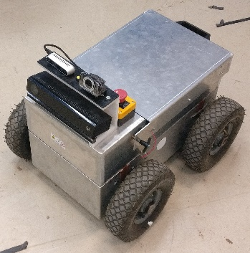

Figure 1- Mobile Robotic Platform

## Experiments

Tests set 1: SLAM with Kinect- in these tests set were checked SLAM using the Kinect camera only, without encoders and other sensors, in different type of lights in the lab and in the greenhouse, to simulate different part of the day. In this set been made tests in the lab and greenhouse during different time of the day and in different time of the year.

In the last part of this set encoders have been mounted on the shafts and added to localization calculations with the Kinect camera and been tested in the lab.

Tests set 2: SLAM with RealSense depth camera – in these tests set SLAM using only RealSense D435 without encoders and RealSense D435 with encoders were checked inside the lab. The tests conducted in different type of lights in the lab, simulating different part of the day.

Tests set 3: autonomous drive with Kinect – the first part is to create a 2D map that contains obstacles and free space where the platform can pass freely. The second part is to send desired point in the space and that the robot will reach to this point, using Kinect camera with encoders.

Tests set 4: autonomous drive with RealSense – the first part is to create a 2D map that contains obstacles and free space where the platform can pass freely. The second part is to send desired point in the space and that the robot will reach to this point, using RealSense camera with and without encoders.

Tests set 5: HUB-CI– in the set several types of communication tested for communicate wirelessly between robots or robot to remoted \*\*\*PC/Expert/Center\*\*\* for information sharing and dynamic decision-making.

In these tests, the following types of communications were tested:

1) Other PC in ARL wireless network send commands via ROS – the platform NUC PC connected via Wi-Fi to ARL network. Another PC with ROS in the same network sends and receives messages with data and commands to the robot.

2) Control to the platform PC from outside ARL network via TeamViewer- the platform NUC PC in ARL (Israel) controlled from another PC in Purdue university, USA about 10,000 km away via TeamViewer. The operator in Purdue can control the movement of the platform with his PC keyboard; can see the 3D map that created with the depth sensors.

3) Control via TeamViewer on other PC in ARL wireless network and send commands via ROS – this test is superposition of tests )a( and )b( – in this test an operator from Purdue controlled on PC with ROS at ARL network via TeamViewer and through it send and receive messages with data and commands to the robot.

4) Transfer data and commands via Dropbox – series of commands entered to excel file in Dropbox folder by operator in Purdue University, and script on the NUC PC read this commands and react according them.

# Results

Tests set 1: in this set SLAM was created by the Kinect. In the first part (Kinect only-without encoders),While the 3D map that received was good early in the morning and late afternoon when the sun radiation is low and doesn’t interrupt to infrared sensors (figure 2), the localization didn’t work well and lost his current position, especially when turning, what caused to drive the platform relatively slow.

After the encoders added to the Kinect the localization improved dramatically and the speed drive of the platform increased. The localization also worked fine and the robot did not lose his position in the space when the Kinect did not work in direct sun light. \*\*\* need to perform test in the greenhouse with encoders\*\*\*\*

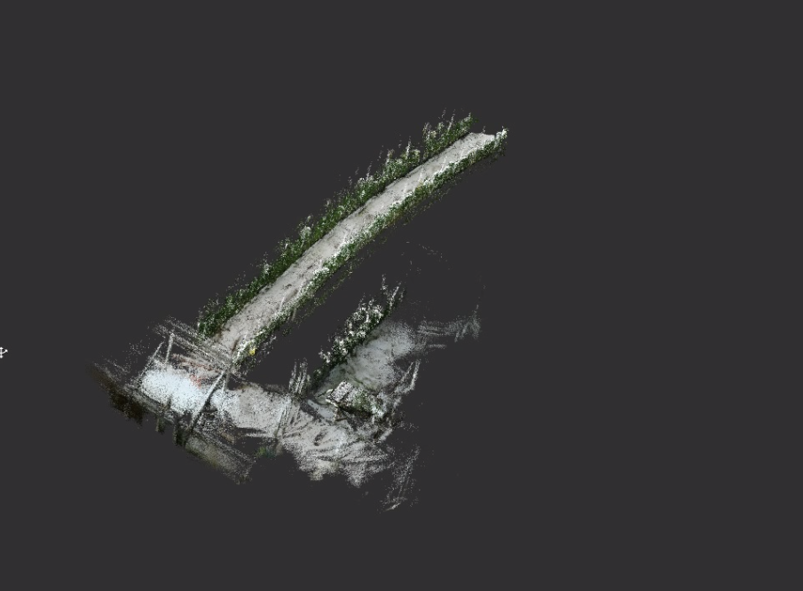 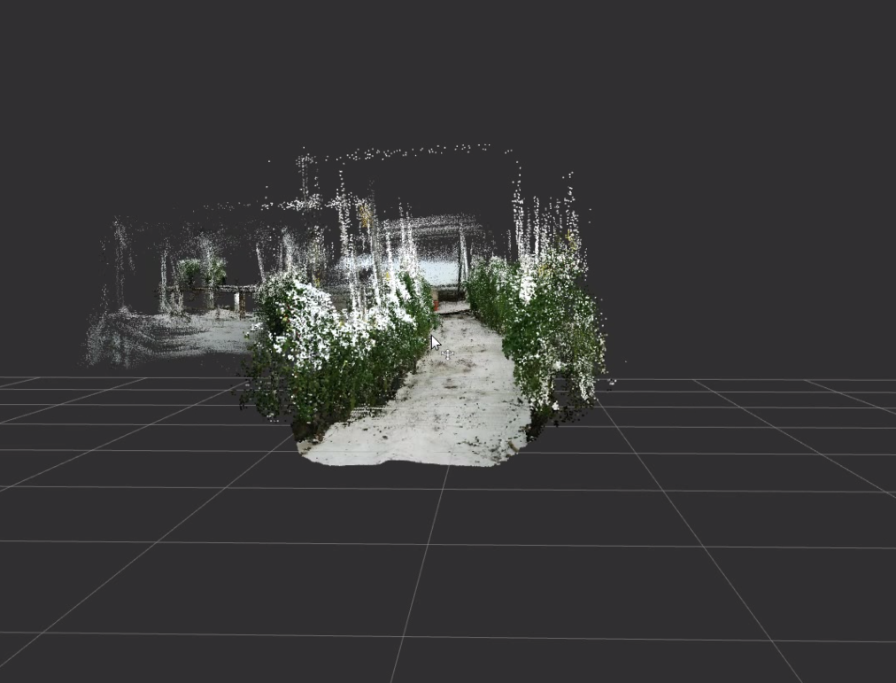

Figure 2 - Greenhouse 3D map- Kinect

Tests set 2: in this set SLAM was created by RealSense. In the first part (RealSense only) inside the lab, SLAM worked good in the desired velocities, created good 3D maps. \*\*\* need to perform test in the greenhouse \*\*\*

After the encoders added, there is no noticeable improvement inside the lab from the results without the encoders (figure 3). \*\*\* need to perform test in the greenhouse \*\*\*

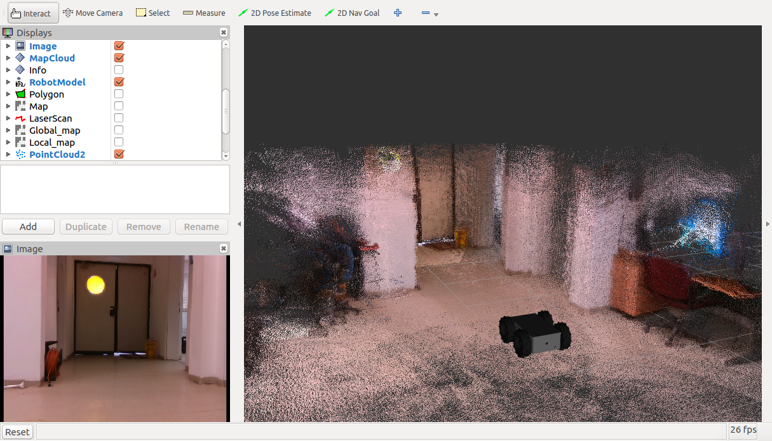 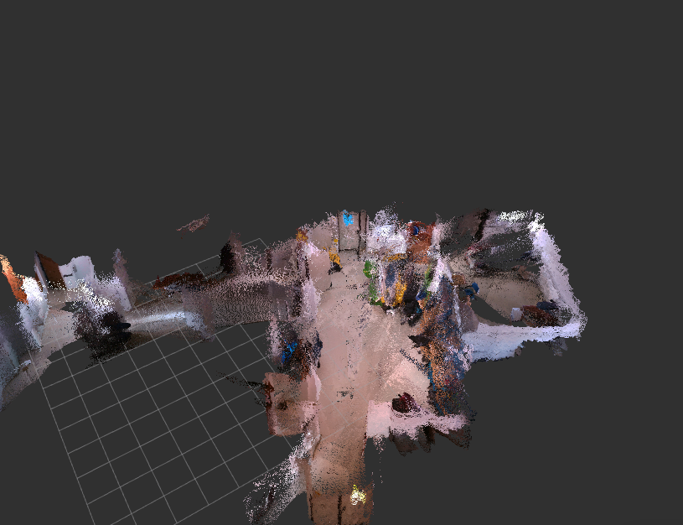

Figure 3 - ARL Lab 3D map- RealSense

Tests set 3: inside the lab, a 2D map was created successfully, using Kinect, but the platform did not reach to the desired point. \*\*\* need to perform more test+ test in the greenhouse \*\*\*

Tests set 4: with RealSense + encoders inside the lab, 2D map was created successfully (figure 4) and the platform reach to the desired point. \*\*\*small rotation problems\*\*\* \*\*\* need to perform test in the greenhouse \*\*\*

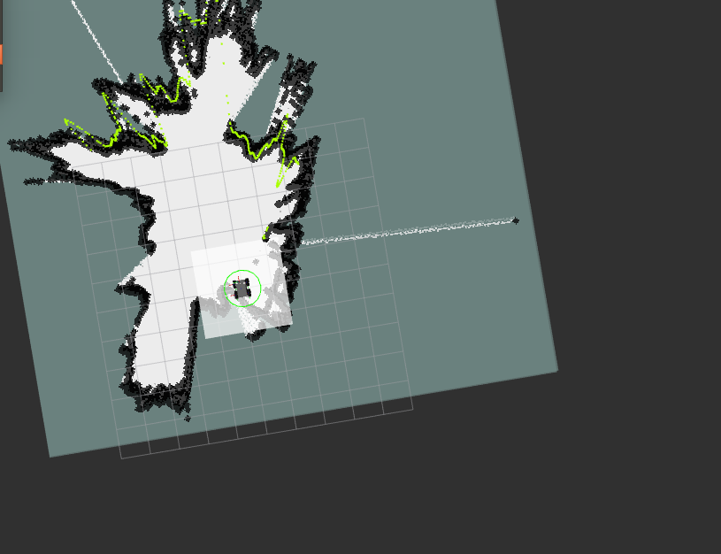

Figure 4 - ARL lab 2D map -RealSense

Tests set 5: in these tests communications types were tested for the collaborative control system, HUB-CI.

1) In this part of the test PC with ROS managed to see all the data from the platform PC, including 3D map, location of the robot, data from all the sensors. In addition, the PC controlled successfully the movement of the platform from its keyboard and send command that simulated the action of take spectral image of the plant. This part tested inside the lab and in the greenhouse.

2) In this part, a remote operator controlled the NUC PC of the robotic platform through TeamViewer. This shows the goal of good communication and transfer data in real time is reached.

3) For effectively communication between units, ROS need that all the unit will be in the same network. According this, remote operator, at Purdue University, controlled a PC in ARL network through TeamViewer. With this PC, with ROS installed, the operator communicate with the platform and successfully simulated collaborative control in real time. The operator succeeded to see the SLAM map, send command to capture picture and to see what the robot view (figure 5). This part tested in the lab and outside the lab at nearby orchard at ARO.

4) In this part, the communication between Purdue University and ARL was performed through Dropbox. Even the commands and data were transformed successfully between the units there was a delay of few seconds between commands, it might be enough for the research purpose but not for commercial use.

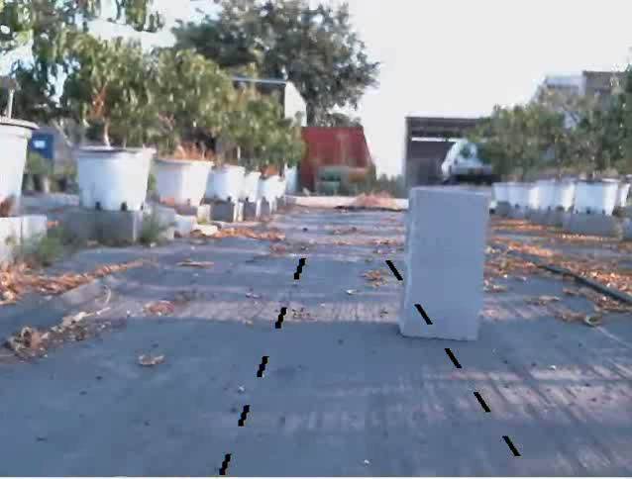

Figure 5 - Remote operator view

# Conclusions

Even that the project does not over yet, those are preliminary results and more tests will be done it can be seen some important conclusions:

As shown at results from tests set (1) and tests set (3) – using Kinect for SLAM and autonomous driving is possible in close areas that do not have strong sun radiation, like places without big glass windows or greenhouses at early / late hours of the day.

It is possible even to get satisfy results if using encoders that help to localization.

From the results from tests set (2) and tests set (4) – using RealSense D435 for SLAM and autonomous driving give good results also in closed areas, like the lab and in open areas with direct sun radiation as greenhouse and orchards.

From these four tests it come that the use of Intel RealSense D435 is giving better result for both SLAM and autonomous driving from Microsoft Kinect.

Tests set (5) shown that the robotic platform can be controlled and communicated with remote units and be part of collaborative control system for early disease detection, but more efficient communication method is required. In the near future VPN will create between ARL, Purdue and UMD to simulate that all the research centers are in the same network and the data will reach to all the centers simultaneously in real time.

## Upcoming work

As mentioned before the project does not over yet and more work is needed.

In the part of SLAM and autonomous driving last experiments in the greenhouse is needed to get conclusions about the desired depth camera or integration between the two options.

In the part of communication VPN need to be finished and test the collaborative control through the VPN.

Other part that need to be done and not discussed here and need to be done is control the manipulator to reach the desired positions to bring the spectral camera for detecting diseases.

The last part to do is integration between all the subsystems and conduct full system experiments.

## Acknowledgements

# Instructions (delete all instructions, blue text, on all pages )

This Microsoft Word document includes particular Word styles, provided by ASABE, that are required for internet search indexing of your paper. The same Word styles provide a professional appearance. If you type or paste your material into the correct places (in the index boxes and at “Click here...”) the styles will be correct automatically.

You can see the styles in Word on the Home tab in the Styles section. To see styles next to your text, go to File / Options / Advanced. In the Display section, in the box beside “Style area pane width in Draft and Outline views,” enter a value of “1” and select “OK.” On the View tab, select “Draft.” Styles will appear to the left.

***Do not change the ASABE styles for the indexing boxes, title, authors, address, conference information, abstract, keywords, and references.*** The default, required, style names for these elements are Authors, Affiliation, Meeting Info, Paper Number, Title, Author(s), Address, Conf Name, Conf Sponsor, Conf Location, Conf Date, Other Pres, Abstract, Keywords, Ref Title, and Ref Listing.

ASABE styles for the body of your paper are Normal, Heading 1, Heading 2, Heading 3, Equation, Figure, Figure Caption, List Bullet, List Number, Table Caption, Table Contents, and Footnote. You may use other styles in the body of your paper.

Click these links for additional information about [Word Styles](http://wordfaqs.mvps.org/DisplayStyles.htm) and for other [information for authors](http://www.asabe.org/publications/authors.aspx).

# Main Body (main headings use this “Heading 1” style)

Start a new paragraph with a single click of the Enter key, without a tab. Paragraphs will be indented.

Use styles for normal text, headings, figures, tables, captions, lists, etc. You may also use *italics*, **bold**, underlines, superscripts and subscripts. Generally use the Times New Roman font. For Greek letters and special symbols, use the Symbol font where possible. Avoid unusual symbols.

Type your text, highlight it, and select the appropriate style from the Styles tab. The text will change to the proper format when you apply the style.

Citations in the body of the text use the name, date system. For example, “Brown (2016) stated that... while others (Smith, 2011; Smith and Jones, 2013; Jones et al., 2014) found that....”.

## Secondary Headings (this text is in the “Heading 2” style)

### Safety Emphasis (this text is in the “Heading 3” style)

You are urged to discuss the effects of your research, concept, design, technique, material, etc., on personal safety, if applicable. In what ways did you consider safety in your project? How will your work improve safety? What precautions do you plan or recommend for eliminating the adverse effects?

## Equations

Use the Word **“Equation”** style. Plain text may be used for a simple equation. MathType is preferred for equations, but you may use the built-in [Word equation editor](http://www.addictivetips.com/microsoft-office/add-math-equations-with-word-2010-equation-editor/). Put the equation reference number outside the equation editor box. Tabs are set up to center the equation and to place the equation number at the right margin.

This is a plain text equation using the **“Equation”** style, with tabs before and after:

*E* = *mc*2 (1)

where

*E* = kinetic energy

*m* = mass

*c* = the speed of light

## Figures (graphics, photos, charts, etc.)

Figures generally follow the paragraph where they are first mentioned. Use the Word **“Figure”** style for the image. Have a caption under each figure using the Word **“Figure Caption”** style.See example below.

The Word drawing canvas is best avoided. Only use it when absolutely necessary, namely, to constrain floating pieces, such as arrows, within a figure.

For digital camera images (JPEG), use the medium or large file setting, not the small file (low quality) setting. For scans and other images, use 600 dpi for black and white line art or 300 dpi for color or grayscale. Higher resolution will not increase the quality of the published image.

Color figures will display in color in the web version but are printed in grayscale. Please print your color figures as grayscale and verify that they can be interpreted correctly, since the loss of color may make lines and gradients indistinguishable.

The font used inside a figure is different than the font used for the text of this paper or the figure caption. *Use a sans serif font, such as Arial, for all lettering inside figures to provide better clarity.* After making the image the size you want, the font within the figure should be 6 to 8 points. The caption uses Times New Roman font.

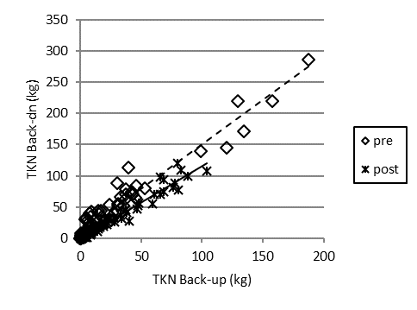

Figure 1. Use the “Figure Caption” style for the caption below each figure. The figure caption should be separate from the graphics image. You may put your figures in tables to aid layout. Use Times New Roman font for this figure caption.

## Tables

Tables generally follow the paragraph where they are first mentioned. Tables use the **“Table Contents”** style. The caption at the top of each table uses the **“Table Caption”** style.

Table 1. Use the “Table Caption” style for the text. Material in the table uses the “Table Contents” style. Use the Word table tools or copy tables from Excel.

|  |  |
| --- | --- |
| Material in the table uses the “Table Contents” style. | Internal line weight 0.5 point. The lines at the top and bottom of the table are 1 point.[a] |
| There is no line below the footnotes. |
| [a] Footnotes use superscripted letters in brackets. Order them left to right, then the next row left to right, etc. | |

## Lists

You may use the **“List Bullet”** or **“List Number”** styles for your lists. Type the list, pressing Enter between items. Select all the listed items and apply the style. If Word forces text into the list against your wishes, press Backspace or select the text and make it **“Normal”** style.

* This uses the **“List Bullet”** style. Use bullets for lists unless numbering is necessary.

1. This uses the **“List Number”** style. Use a numbered list only when the list represents a sequence, such as the steps in a procedure.

# Conclusion (uses “Heading 1” style)

The Conclusion or Summary section restates the major findings and suggests further research. It is the last main heading before the references.

## Acknowledgements (uses “Heading 2” style)

Put any acknowledgements, such as thanks to contributing individuals or organizations, here.

# References (uses “Heading 1” style)

This section (for all references) uses the *APA 6th* style. Reference citations in the text use the name, date system. See those examples in the “Main Body” section above.

**NEW—In this section, we encourage the use of** [**EndNote**](https://www.youtube.com/watch?v=dA8SAMZo0xw) **(preferred) or the** [**Microsoft Word References tool**](https://support.office.com/en-us/article/Create-a-bibliography-3403c027-96c8-40d3-a386-bfd5c413ddbb) **in Word 2007 and later. See this** [**video**](https://www.youtube.com/watch?v=8WZjD2Qxa3Q) **or** [**these instructions**](https://support.office.com/en-US/article/Create-a-bibliography-17686589-4824-4940-9c69-342c289fa2a5)**. Choose *APA 6th* style and the** [**ISO abbreviations for journal names**](http://www.issn.org/services/online-services/access-to-the-ltwa/) **(LTWA).** [**JabRef**](http://jabref.sourceforge.net/help/JournalAbbreviations.php) **(free download) can** [**automate**](http://jabref.sourceforge.net/help/JournalAbbreviations.php) **journal abbreviations for the ISO standard. JabRef can** [**export references**](http://www.paulkiddie.com/2009/07/jabref-exports-to-word-2007-xml/) **to “MS Office 2007 (\*.xml)” that can easily be imported into Word References.**

**If you use the Word References tool or EndNote and select *APA 6th*, all of the details of format described below will be done for you automatically when you create a bibliography.** Make it the **“Ref Listing”** Word style to create the indents.

**For those of you NOT using EndNote or Word References tool,** please compose your reference entries following the examples below, which follow the *APA 6th* style, and put the references in alphabetical order. (Word will do this for you under the Paragraph function).

Make the reference list the **“Ref Listing”** style.

List author names with last name first, then initials. List up to seven authors per author group; for sources with more than seven authors list the first six names, then an ellipsis (periods and spaces, . . . ), then the name of the last author, as in the first example.

For all titles, capitalize the only the first word, the first word after a colon or dash, and proper nouns. Titles of books and journals are italicized; other titles (book chapters, journal articles, papers from a meeting, reports, standards) are not italicized.

Do not use a period after a URL.

## Examples:

## Journal Article

Firstauthor, A. B., Second-Author, E., Thirdauthor, F. G., Fourth, H. I., Fifthauthor, J., Sixthauthor, K.L., . . . Lastauthor, Z. (2017). Title of journal article: Capitalize after colon. *Appl. Eng. Agric., 578*(12), 5-10. http://doi.org/10.1111/11111

## Book

Lastname, A. B., & Jones Jr., C. D. (2014). *Book title.* Location of publisher: Publisher.

Surname, X. B., Author, C. D., & Jones Jr., E. (2017). *Book title* (2nd ed., Vol. 3). St. Joseph, MI: ASABE.

## Section of a Book

Author, A., & Secondauthor, B. C. (2017). Section or chapter title. In *Book title* (pp. 17-34). Washington, DC: USEPA. Retrieved from www.epa.abcdefg.gov

Chapterauthor, A. (1987). Section or chapter title. In B. Bookeditor & C. Bookbinder (Eds.), *Book title* (2nd ed., Vol. 3, pp. 17-34). Rome, Italy: FAO.

## Paper from a Meeting, Conference Proceedings Include the name and location of the publisher, but not the location or dates where the meeting was held. Abbreviate Conf., Int., Proc., Symp.

Author, A. B. (2018). Title of paper. In B. Editor (Ed.), *Proc. 10th Int. Conf. Agricultural Engineering. 2*, pp. 655-766. Washington, DC: USDA-ARS. [http://doi.org/10.12/4x.57](http://dx.doi.org/10.12/4x.57)

Author, A. B., & Name, C. D. (2014). Title of paper [in Chinese]. *Proc. 10th Symp. Agricultural Engineering*. Publisher location: Publisher.

Author, A. B., & Name, C. D. (2016). Title of paper. ASABE Paper No. 1601234. St. Joseph, MI: ASABE.

## Standard

ASABE Standards. (2018). S358.2: Moisture measurement—Forages. St. Joseph, MI: ASABE.

ASTM. (2014) 12343: Standard name. West Conshohocken, PA: ASTM Int.

## Dissertation or Thesis

Author, A. (2014). Title of dissertation. PhD diss.[or MS thesis.] City, state or nation: University Name, Department of Engineering.

## Miscellaneous If no author listed, use the name or abbreviation of the organization.

ABCD. (2014).Title. Association of BioCropsDiversity. Retrieved from <http://bcd.org/report.pdf>

Author, A. B. (2018). Patent title. U.S. Patent No. 123,456.

SAS. (1990).SAS User’s Guide: Statistics. Ver. 6a. Cary, NC: SAS Institute.

USDA-NASS. (2004). Report title. Bulletin 1234. Washington, DC: USDA-NASS. Retrieved from [www.usda.nass.gov/x1234.pdf](http://www.usda.nass.gov/x1234.pdf)

## Unpublished Material Do not list such material in the References section because it is not available to the reader. Put useful information in the text of your manuscript, e.g., “. . . this was rare (Charles Brown, USDA-ARS, personal communication, 23 May 2018).

# Appendix or Nomenclature (optional)